**Dog Park Location Comparison**

These documents are available at www.teamdesignarch.com

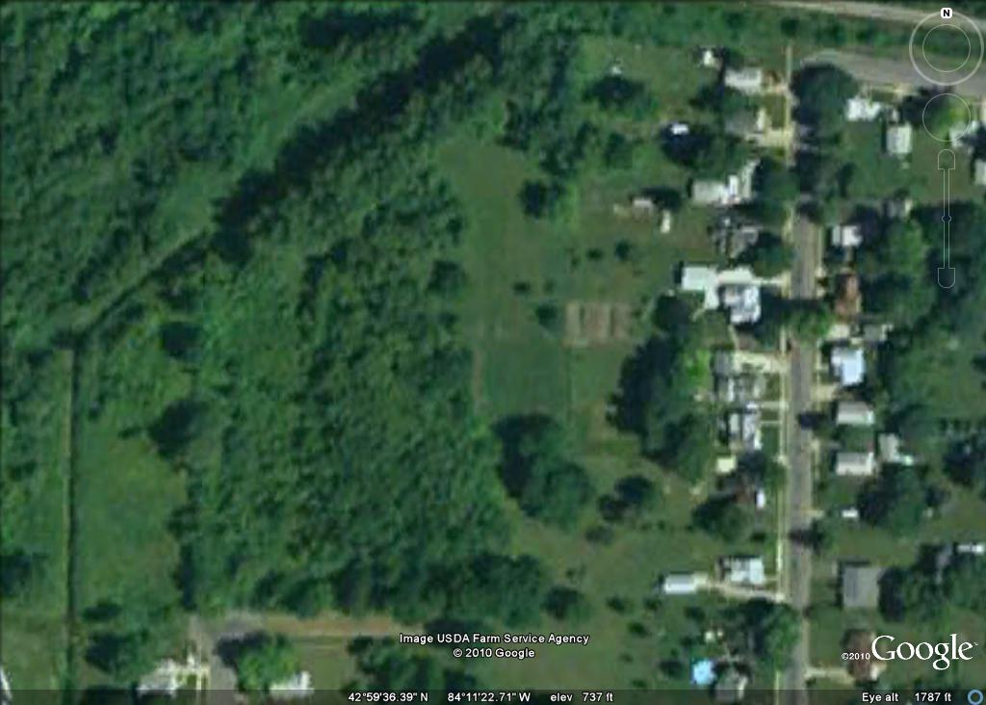

Rain Street

Pros:

Large, unused area

Lots of trees

Cons:

No existing infrastructure; parking, water, etc.

Not centralized, difficult to find

Close neighbors

High start up costs

*All images are at the same scale. The black box represents an area of about ¾ of an acre and is the same on all images*

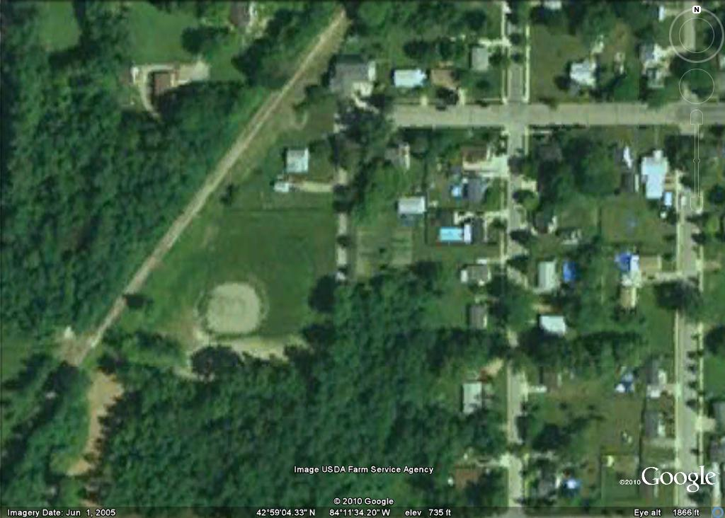

Lyons Park

Pros:

Large, unused area

Existing fence that needs repair

Cons:

No existing infrastructure; parking, water, etc.

No mature trees

Not centralized, difficult to find

Close neighbors

High start up costs

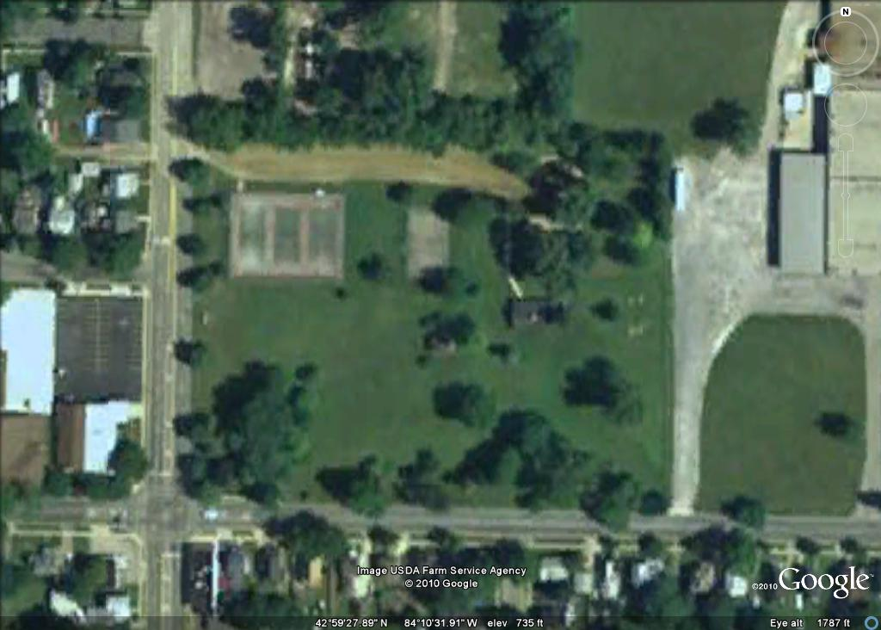

Bentley

Pros:

Large, centralized park area

Easy to find, great location

Lots of mature trees

Water and restrooms available

Lots of parking

Great possibility for a destination park

Lots of useable fencing

Low start up costs

Cons:

Some neighbors

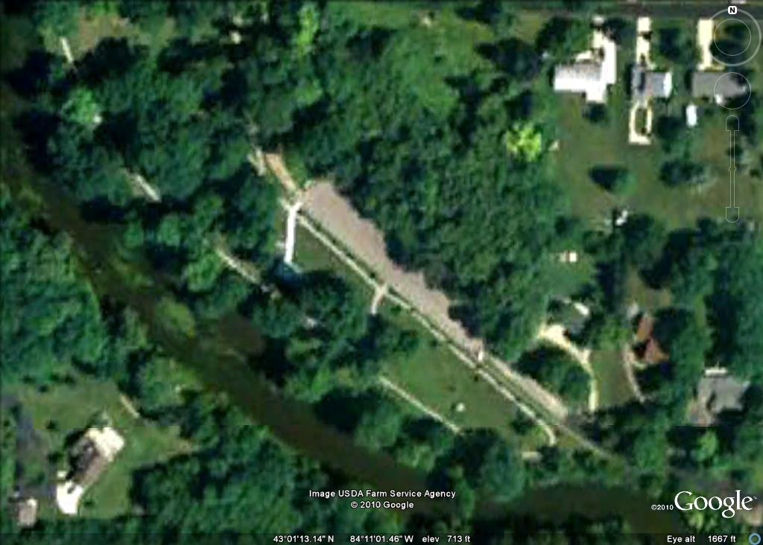

Harmon Partridge

Pros:

Large park area

Adjacent river, could also be a con

Lots of mature trees

Lots of parking

Possibility for a destination park

Cons:

No restrooms

Some neighbors

No useable fencing

High start up costs

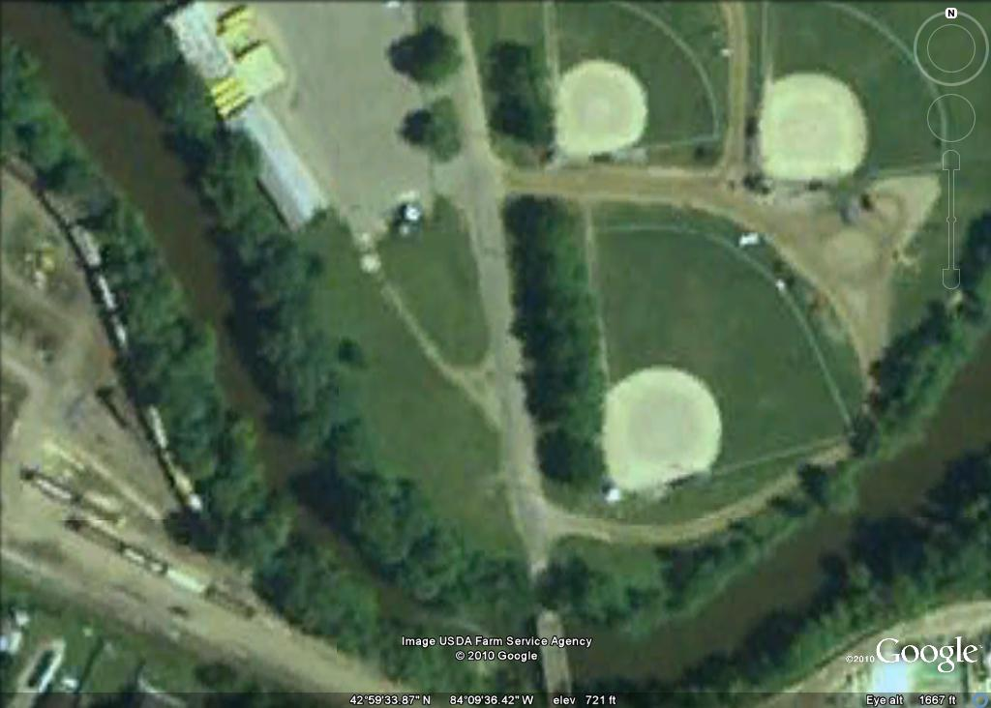

Bus Garage

Pros:

Large park area

Adjacent to river loop

Some mature trees

Lots of parking

Already used for softball and river loop

No neighbors

Medium start up costs

Cons:

No restrooms

Very little useable fencing

Not easy to find

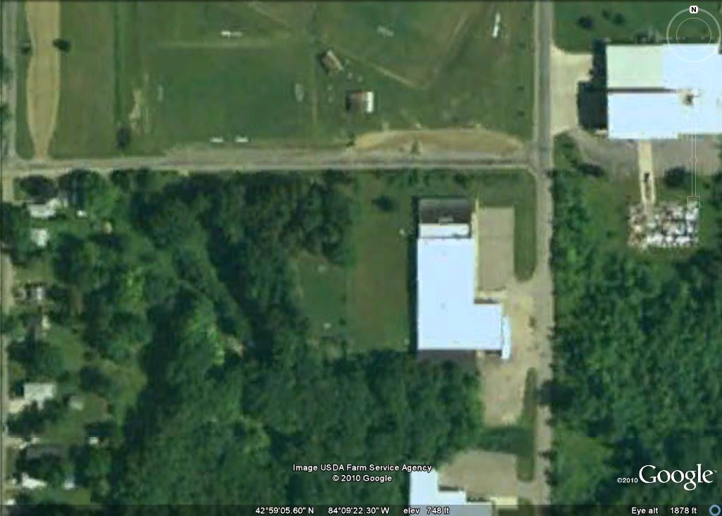

Roseverre

Pros:

Large park area

Lots of mature trees

Lots of parking, no parking lot

Site already used for soccer fields

Very few neighbors

Cons:

Site already used for BMX

No restrooms

No useable fencing

Tree removal required

High start up costs

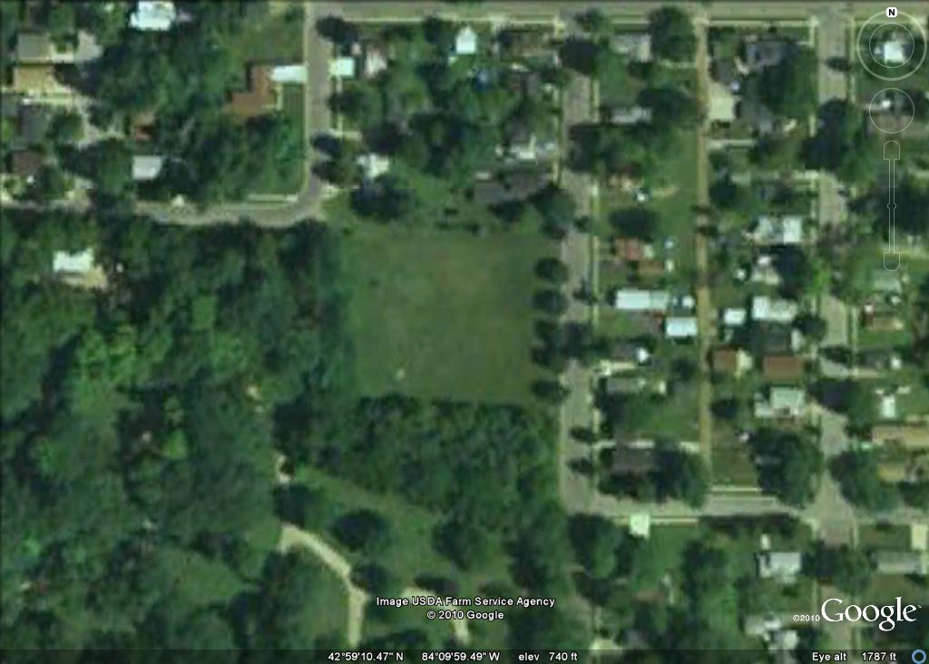

Grand Ave

Pros:

Large park area

Site already used, by some accounts

Fencing may be adequate but is quite short

Cons:

No parking

Many neighbors

No mature trees

No restrooms or water

No useable fencing

Hard to find

Medium start up costs

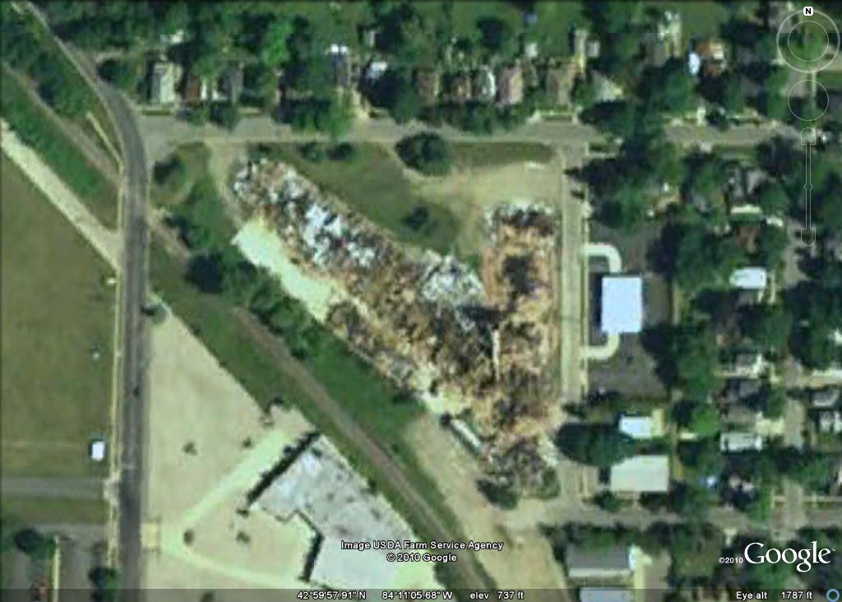

Vanguard

Pros:

Large park area

Lots of Potential parking

Cons:

No mature trees

No restrooms

No useable fencing

Site may be toxic, will require cleanup

Potentially very high start up costs

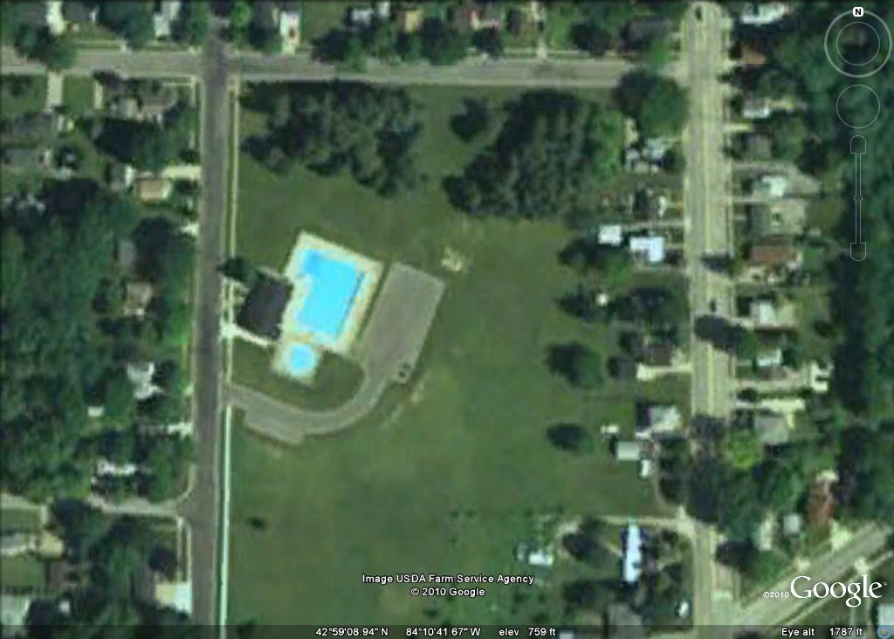

Holman

Pros:

Large park area

Lots of mature trees

Lots of parking

Restrooms are available at pool building

Possible destination park

Low to medium start up costs

Cons:

No useable fencing

Some neighbors